VISWAJYOTHI COLLEGE OF ENGINEERING & TECHNOLOGY
DEPARTMENT OF COMPUTER SCIENCE AND ENGINEERING
UNIX SHELL PROGRAMMING
- Familiarization of basic Linux Commands
- Use the command to find out about the users logged into the system. Also determine your login shell
- Use a command to find the local and universal time
- Write a command to show the date using following format
- Use a command to display the whole calander for the current year
- Use a command to get the calandar for the current month
- Display the calandar for the october 2006
- Use cal command to determine the year 2000 is a leap year or not
- Getting started with Linux basic commands for directory operations, displaying directory structure in tree format etc.

- Create a directory calld stud in Desktop. Create a directory under stud directory called marks.
  - Copy any two files from the HOME to marks. Delete the directory marks
  - Copy any two files from the HOME to STUD. Create additional name for them
- You will create a file and directory structure, record it using a listing command and output redirection, and then change the structure and record its change with another listing command.
- In your home directory, create a directory called filefest.
- Inside this directory filefest, create set of directories and files as shown in the following diagram. Use the UNIX command mkdir to create a directory. Use whatever means you would like to make the files, such as output redirection or the Unix touch command. The contents of the files can be anything (or empty), but they must be plain text files, and you must use the exact names as shown in the diagram.

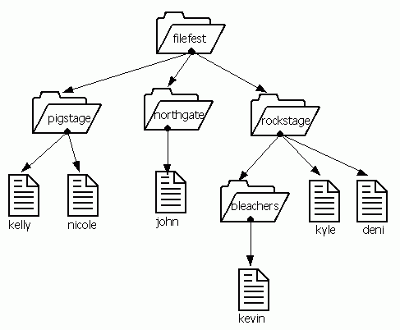
In this diagram, there are three directories under filefest: pigstage, northgate, and rockstage. In pigstage, there are two files: kelly and nicole. In northgate, there is one file: john. In rockstage, there are two files--deni and kyle--and one directory, bleachers. In bleachers, there is one file, kevin.
- In the filefest directory, look at the directory structure you have created by using the UNIX list command ls -lR.
- Still in the filefest directory, do the ls -lR command again, but this time redirect the output of this ls -lR command to a file called listing.
- Now move all the files in the directories pigstage (kelly and nicole), rockstage (deni and kyle), and bleachers (kevin) to northgate.
- Now delete the directories pigstage, rockstage, and bleachers.

Once you have moved the files and deleted the directories, you would have this structure:
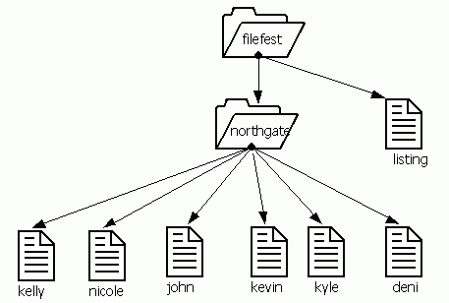

- Still in the filefest directory, use the ls -lR again to look at the new file structure you have.
- Still in the filefest directory, append the output of this ls -lR command to the file listing.

- Create a directory called ‘dept’. Create subdirectories called ‘fin’,’pers’ and ‘mktg’ under the ‘dept’ directory. Create two sub directories under ‘fin’ called ‘exp’ and ‘inc’. Create 2 subdirectories under ‘pers’ directory called ‘admn’ and ‘pay’. Under the ‘exp’ directory create two files called ‘ent’ and ‘postage’. Create two files ‘fees’ and ‘sales’ under ‘inc’ directory. Create two files ‘exp’ and ‘reco’ under ‘admin’. Create 2 files ‘add’ and ‘ded’ under ‘pay’ directory. Create 2 files ‘salesinfo’ and ‘pur’ under the ‘mktg’ directory. Answer following questions based on this
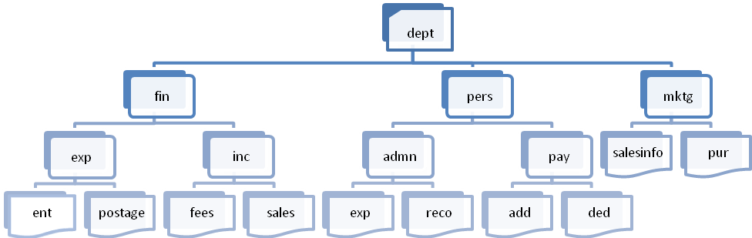
  - Copy ded to the mktg directory. Rename it as deduc
  - Copy salesinfo to pay directory and move it to the exp directory under the name sinfo. Copy the same file to the fin directory and remove the file sinfo in exp directory
  - Rename the file postage to pexp and move it to the pers directory. Now create the link for the same file and remove the pexp file
  - List the named of all files whose names begin with ‘e’ under ‘dept’ directory
  - Delete all the directories and all files created, including the dept directory
- Redirect the content of ls -p to a file called dir. Also give a command ls –l and append the output to the same file dir. Display the file dir
3. Linux commands for operations such as redirection, pipes, filters, job control, changing ownership/permissions of files/links/directory

- Create file ‘emp’ using cat command and separate each field with tab.Each field contains empid,First name, last name and title roll
112 | John | Roy | Team Leader
045 | Yamuna | Sarath | Senior Engineer
345 | Delna | Wilson | Junior Engineer
234 | Lakshmi | Binu | Trainee
567 | Ganga | Vibin | Trainee
568 | Abja | Rajesh | Trainee
348 | Alan | Wilson | Project Leader
200 | Reenu | Thomas | Trainee
112 | John | Roy | Team Leader
567 | Ganga | Vibin | Trainee

  - Print the number of employees and size of file
  - Print the line number for the file emp and save it to another file emp1
  - Search for the employee ‘John’ whether present in the list or not
  - Cut employee id to another file empid
  - Cut first name and last name to another file nameemp
  - Convert lowercase to uppercase in nameemp and save it to the same file
  - Paste the empid and nameemp to one file emp2
  - Sort the file emp2 according to name and save it to another file emp3 and delete file emp2
  - Sort the file emp according to empid and save it to another file nemp and delete emp
  - Use uniq to display the duplicated details of employee in file nemp and delete the duplicated entried and save the result to the new file nemp1
  - Display the details of first 3 employees in the file nemp1 and save it to another file jemp1
  - Display the details of last 4 employees in the file nemp1 and save it to another file jemp2
  - Use cut and paste to swap the first name and last name save it to another file names
  - Using join command join 2 files jemp1 and jemp2 and display the result
  - Sort jemp1 and jemp2 based on their names and compare the files and display the result
  - Use cmp compare the files jemp1 and jemp2
  - Use diff to compare the files jemp1 and jemp2
- Create a long list of the current directory and sort the list in reverse order using pipe and without using any temp files. Display the result to the monitor
- Use the ls –l command and try to send result to the two files file1 and file2 using pipe and tee command

- Shell Programming
- Write a shell script to print a message on the screen
- Write a shell script to accept your name and print it to the screen
- Write a shell script to add 2 numbers
- Write a shell script to multiply 2 numbers
- Write a shell script to find the largest of 2 numbers
- Write a shell script to print the result home directory, date, who using case construct
- Write a shell script to print the multiplication table using for loop and while loop
- Write a shell script for a simple calculator
- Write a shell script to accept a file and check whether the file exist or not
- Write a shell script to accept file name as arguments and convert all of them to uppercase provided they exist in the current directory
- Write a shell script to accept any 3 numbers as command line arguments and check that the correct number of arguments was received and print an usage message if not,
- Write a shell script to show whether the given string present in the given file where the file name and the pattern to search should be passed as command line arguments
- Write a script called addnames that is to be called as follows, where ulist is the name of the classlist file, and username is a particular student's username. The script should
sh addnames.sh ulist username

  - check that the correct number of arguments was received and print an usage message if not,

  - check whether the classlist file exists and print an error message if not,
  - check whether the username is already in the file, and then either

  - print a message stating that the name already existed, or

  - add the name to the end of the list

